Brief tutorial for ANALYZE
A bare-bones introduction written by Mike Cole, 6-7209.

Warning: ANALYZE can give misleading results if any rows or columns have names > 8 characters long.

- Go to the relevant output directory (which was created when you ran jognems).
Ex: N:/output/mc6_working/d110308b

- Type ls *.gz to see the yearly PMM_yyyy.act.gz files. There should be a gz file for each year (unless you have already unzipped a particular year’s gz file.).

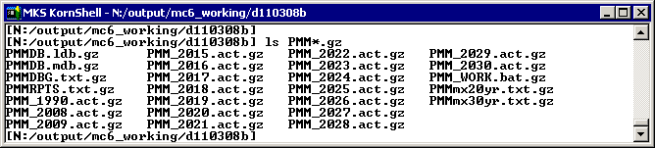

- If you copy the ACT files to another directory, then you must also copy the following OML DLL files:

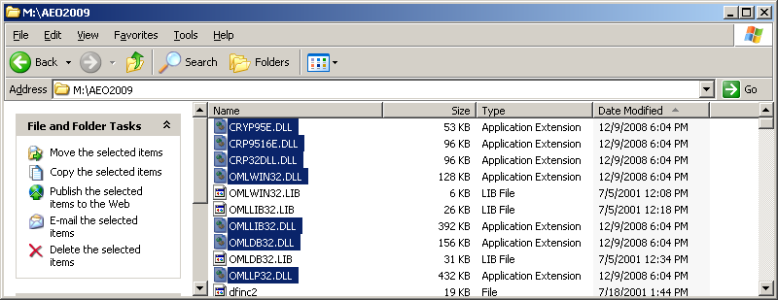

- Unzip the year(s) of interest, e,g: gzip –d PMM_2015.act.gz. Or, try gzip –d PM* to unzip all years.

- Run pack_all. Enter the relevant year (or All for all years), and enter PMM as the model. The program will run for a few seconds and create a PCK pack file (PM15.PCK, in this case). (Note: pack_all requires that all of the OML libraries be in the same directory as the ACT file. This happens automatically with jognems).
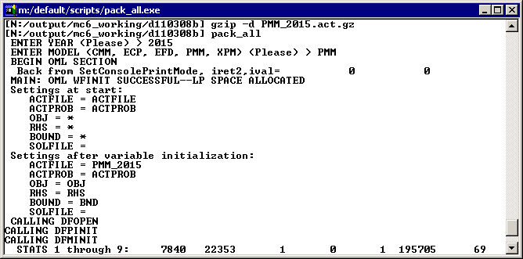

- Type ls -l PM15.PCK to verify that the large PCK file was created.
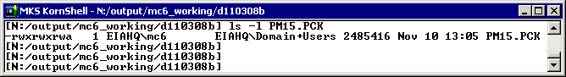
- Type analyze to start the ANALYZE program.
* Verify that HELP and PRINT point to M:/default/analyze (if not, press <enter>, q <enter> to quit, then rm setup.exc from your output directory, and restart ANALYZE).
* Press <enter> to run the default version of ANALYZE.

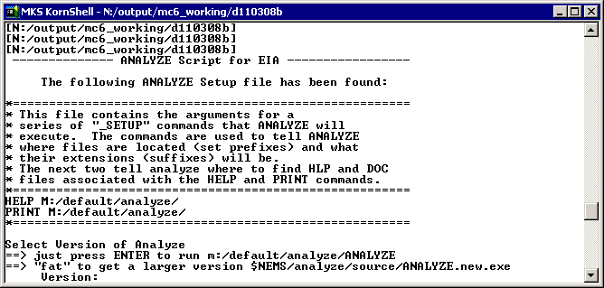

- ANALYZE will display its splash screen. Press the CAPS LOCK key. Type ? if you want to read an introduction. Type HELP to list all of the commands. If you want help on a particular command, such as READIN, type help READIN (note: the command name must be in all caps for the help system to work).
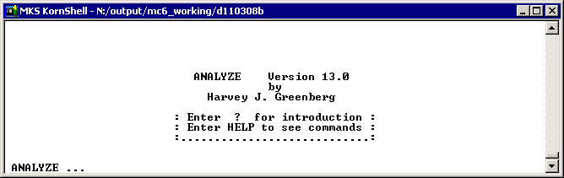
- Type readin p PM15.PCK to read the PCK pack file for year 2015.

- Type L H4CRN,* to list all nonzero columns associated with row H4CRN.
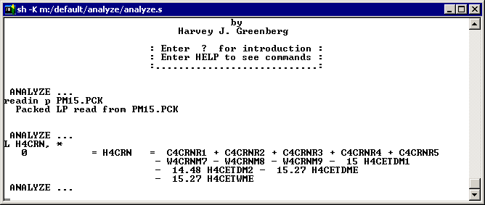
(Note: L H4, * will list all nonzero columns for all rows that had “H4” as the first two characters in the row name. The command L H*CRN, * lists all nonzero columns for rows that have H as the first character and CRN as characters 3-5. The command L H”CRN, X lists all nonzero columns that start with X for all rows that start with H and which then have the string CRN after one or more intervening characters.)

- If you’d like the output piped to a file (such as junk.txt) rather than displayed on the screen, type output junk.txt. In fact, the remainder of this guide makes more sense if you pipe the output to a file.

- The command L H4CRN,* initializes a submatrix comprising the row H4CRN and its nonzero columns..

- Type SUBMAT ADD ROW * to enlarge the submatrix to include all rows with intersecting nonzero columns. Type pic to display a picture of the submatrix.

- Type show col to display the column data (i.e, the nonzero decision variables) associated with the submatrix.

- Type q to quit ANALYZE.

- Examine the output file junk.txt using your favorite text editor.

